THE PRESENT SIMPLE

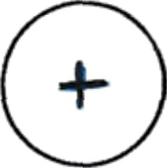
Positive sentence:

 | eat
you | eat
he | eats
she | eats
it | eats
we | eat
you | eat
they | eat

 | gO
you | go
he | goes
she | goes
it | goes
we | go
you | go
they | go

I | f\y
Y | fiy
he | flies
she | flies
it | flies
we | fly
Y | fiy
they | fly

6 S  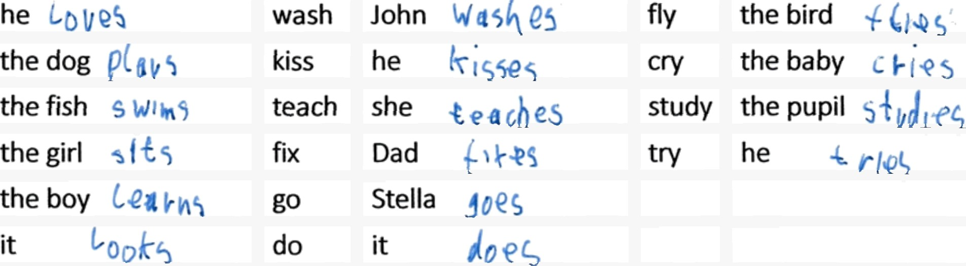  most verbs |  | +es  verbs ending in ch sh, ss, x,o |  | +ies  verbs ending in con ant +
love
play
swim
sit
learn
look

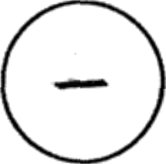
Negative sentence:

I | don't eat | I | don't go | I | don't fly
you | don't eat | you | don't go | you | don't fly
he | doesn't eat | he | doesn't go | he | doesn’t fly
she | doesn't eat | she | doesn't go | she | doesn't fly
it | doesn't eat | it | doesn't go | it | doesn't fly
we | don't eat | we | don't go | we | don't fly
you | don't eat | you | don't go | you | don't fly
they | don't eat | they | don't go | they | don't fly

Do | I | eat?
Do | you | eat?
Does | he | eat?
Does | she | eat?
Does | it | eat?
Do | we | eat?
Do | you | eat?
Do | they | eat?

Do | I | go?
Do | you | go?
Does | he | go*
Does | she | go?
Does | it | go?
Do | we | go?
Do | you | go?
Do | they | go?

Do | I | fly?
Do | you | fly?
Does | he | fly?
Does | she | fly?
Does | it | fly?
Do | we | fly?
Do | you | fly?
Do | they | fly?

